Modern Slavery Statement - 2022
For reporting period of 1st Jan 2022 – 31st Dec 2022

About Medica
Medica is the market leader in the UK and Ireland for the provision of teleradiology services, providing
outsourced interpretation and reporting of MRI (magnetic resonance imaging), CT (computerised
tomography), ultrasound and plain film (x-ray) images. Medica also offers diabetic retinopathy
screening in Ireland.

Medica contracts with the largest pool of consultant radiologists in the UK and Ireland, performing
remote access teleradiology across its customer base of more than 100 NHS Trusts in the UK, the
Irish HSE, private hospital and insurance groups, as well as diagnostic imaging companies. This
enables the Company to offer a fast, responsive service. In addition, Medica operates in Australia and
New Zealand through MedX, a 50:50 Joint Venture with Integral Diagnostics Limited Pty. Through its subsidiary, RadMD, in the United States, Medica also provides pharmaceutical and biotech clients and contract research organisations (CROs) with high quality, complex imaging services for international clinical trials. RadMD has gained vast experience in the space, having contributed to over 500 international clinical trials, in all phases of clinical research from proof of concept to phase III and with expertise in oncology, as well as a wider range of therapeutic areas including medical devices, neurology and cardiovascular.

The Company currently offers two primary services to hospital radiology departments:

- NightHawk - urgent reporting service
- Elective - includes routine cross-sectional reporting on MRI and CT scans, and routine plain film reporting on x-ray images.

Medica Group is the parent company and Medica Reporting Limited is our subsidiary that operates in the UK and meets the criteria for publishing an annual Modern Slavery Statement.

Our Supply Chain
Medica contracts with consultant radiologists to perform remote access teleradiology in the UK and overseas. Our product, the medical report, is provided directly to the client’s RIS by consultant radiologists, each performing as an individual supplier.

To run our business, Medica sources goods and services either directly or through recognised distribution and reseller channels. Respecting human rights and environmental issues in the supply chain is ultimately Medica’s responsibility. As we do not have control of the downward supply chain Medica applies due diligence to the selection and assessment of suppliers from reputable local, national, or international organisations.

Our Policies
Medica’s Modern Slavery Policy reflects our commitment to act ethically and with integrity in all our business relationships. The Policy is communicated to all workers to ensure they understand our responsibility and attitude towards modern slavery. Our wider policy suite instils ethics and integrity across the organisation.

Due Diligence
Medica continues to review and assess its supply chain on an ongoing basis in order to understand where any risk of modern slavery may exist, and how best to respond to any perceived risk. Medica has written to its main suppliers to inform them of our policy and to pass on their specific obligations relating to modern slavery. Our continued due diligence checks will ensure that Medica is compliant with all relevant legislation, and we continue to review our policies and processes to ensure compliance is maintained.

Medica has obtained the Living Wage Accreditation in 2021, reinforcing our commitment to ensure that staff, workers, and third-party contractors are paid a fair wage. To support the accreditation we have conducted an annual review of the hourly rate of all staff, workers, and third-party contractors to ensure that the National Minimum Wage and National Living Wage is being paid in all circumstances. In addition, Medica has instituted its own company-wide minimum wage which exceeds the National Minimum Wage and National Living Wage rates.

All staff recruited by Medica undergo relevant pre-employment checks. This includes vetting the identity and eligibility to work in the UK and ensure a Disclosure Barring Service check is completed. Staff can only receive payment of wages into a bank account that is in their own name (or joint account).

Risk Assessment
Medica strives to understand its business and the circumstances in which it operates to identify any risks of modern slavery. Medica has a robust risk management framework which ensures such risks are assessed, managed, and reviewed at the appropriate management level.

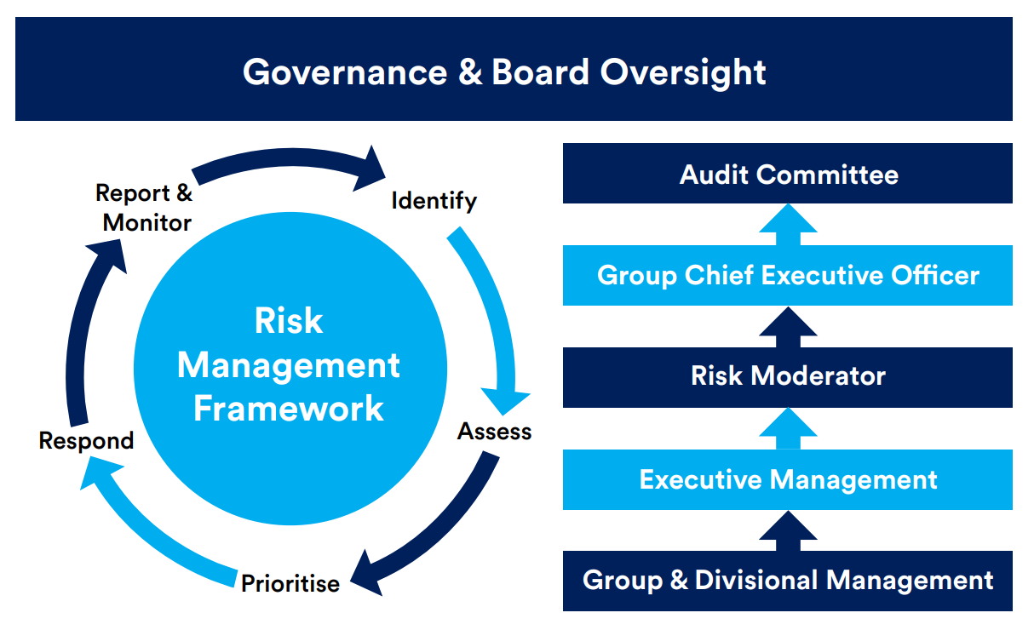

Training and Communication
All new employees follow an induction process that includes mandatory understanding and acceptance of Medica’s policies, procedures, and processes. These documents are readily available to all workers through a central document repository.

Statement Approval
This statement is made pursuant to Section 54(1) of the Modern Slavery Act 2015 and constitutes Medica Group’s annual statement for the financial year ending 31 December 2022. It has been reviewed and approved by the Board of Directors as dated below.

S. Quin
Dr. Stuart Quin
Group Chief Executive Officer, Medica Group
12th May 2023

Approved by the Board of Directors on 18th May 2023

Our previous statement(s) can be viewed via the links below:
Modern Slavery Statement - 2018
Modern Slavery Statement - 2019
Modern Slavery Statement - 2020
Modern Slavery Statement – 2021

[END OF DOCUMENT]

